



Web Marketing Proposal for
The FDA Group LLC

Prepared for Tim Lamm

February 10th, 2014

Prepared by Steven Kent

Protea Digital Marketing

30 South Cricket Terrace,
Ardmore, PA 19003

www.proteadigital.com

Background

The FDA Group would like to grow and improve its online presence.

Scope

This proposal incorporates website design and development, and on-going digital marketing services and management.

Site Development and Design

Your website is a 24/7 representative for your business, and is most often the first impression people have of the company. Having a professional, modern site is key to credibility, and to building awareness, interest and ultimately turning visitors into leads. A high quality site opens the door to higher quality leads.

We’ll have a call to discuss exactly the design you need, and the make sure the look and feel is right. Protea Digital do all the design work, and will then work with you to get the design right, and then integrate the design with an appropriate content management system.

The site will also feature responsive design to ensure the site renders correctly on tablet and mobile devices – also important for search engines.

Protea Digital will also ensure the design is clean and simple, and easy to use.

You will have unlimited input and redesign. We will make sure the site is exactly what you need to take your digital marketing to the next level.

We will optimize the site structure to make sure the site has the best chance of ranking well for relevant keywords

On-going Management

1. Google Adwords Management

- End-to-end campaign management of Google Adwords
- Research keywords and competitors
- Creating campaign/keyword structure to ensure maximum efficiency
- Optimizing the number and types of keywords for increased productivity
- Regular addition of ads and testing of ad content to maximize sales
- Design improvements and recommendations to increase conversions
- Remarketing campaigns to target and reengage one-time visitors
- Advertising on competitor keywords
- Clear monthly reports

2. LinkedIn Advertising Management

LinkedIn has a useful advertising feature, which allows the targeting of individuals and companies. This can feed to landing pages on the site. We can also use data from the visitor ID software to target companies we know have visited the site. Individuals can be targeted for ads by job title and industry. We would suggest a small LinkedIn Ad campaign to test the ROI on this channel. Protea Digital handles the end-to-end management and setup.

3. Content Development

Protea Digital will help you build up a resource section. This will contain quality articles, white papers and other forms of content to help engage potential customers. We have worked with companies before to write high quality four to five page white papers and articles. Building assets in the resource section helps to build an audience, keeps visitors engaged, and is great way to draw in previous visitors to reengage with the site. It also helps with the perception of the firm as a thought leader as well as adding to credibility. Relevant, keyword-informed, content is the key to organic search engine optimization, and the best chance of ranking well.
4. Blog Posts

Blogs are the bedrock of content marketing and for social media. A good blog keeps a site fresh and interesting, and is a strong component of organic optimization.

We will post two new blog posts twice a week. Each post will be approximately three to four paragraphs long, sometimes longer. These will help build the FDA Group brand, and be fed to social media.

5. Landing Page Development

Protea Digital will develop specialized landing pages for campaigns and social media. This would allow us to maximize the potential number of leads, and sharpen content.
Testing is an integral part of landing page development, and we use software to facilitate A/B testing to continually improve the conversion rate of the lead generation pages.

6. Social Media Updates

This will be done via Twitter and other appropriate social media channels. There will be links to content added on the site, and promotion of resources such as white papers. A smart social media approach amplifies the website, and draws in new visitors by making valuable content easy to share.

7. Email Marketing Updates

We can help you develop quarterly email newsletters. We provide email marketing software to help ensure compliance, and use best practices to promote high open rates and click-thru rates. We track opens, and use this information to segment the list. Protea Digital has relationships with best of breed segmentation providers. We are also always looking for ways to grow the email subscriber list, as this is a valuable, permission-based channel. Protea Digital has experience in email design and development to help keep potential customers engaged.
8. Visitor ID on Website

We include software which identifies website visitors, and identifies the company they are from. For example, you would see visitor from “Merk, Inc” in New Jersey. This can be useful for sales and identifying potential leads, and clients have used this with great success in the past.

9. Reporting and Analytics

You will have access to all analytics, and be able to see all the relevant data at anytime. We also send a clear monthly reporting showing analytics such as visits, clicks, conversions, spend, time on site and more. You can also contact us at any time to request any further information. We are transparent with all data.

10. Software Integration

Protea Digital will ensure that all the appropriate analytics tags are installed and working correctly. We will also make sure that all software is correctly integrated with the site and operating smoothly.

11. Site Hosting

Protea Digital will also provide hosting for the site. It will be stable, fast and ensure extremely high-uptime.

12. Unlimited Strategic Recommendations

We have worked with a number of B2B clients and are happy to offer strategic recommendations and best practices. We draw on extensive knowledge and experience with fast growing B2B companies. Protea Digital takes a partnership approach, and if we uncover opportunities or channels which will help you grow, we will recommend them to you, and implement them.

13. Unlimited Phone and Email Availability

You are welcome to contact us at anytime and we will respond quickly. We pride ourselves on clear, responsive communication. You will have our direct phone number and we are always available should you need to talk with us at any stage.

Integration Strategy Benefits

Having an integrated strategy can produce better results than ad-hoc campaigns. A well-run pay-per-click campaign, combined with finely-tuned landing pages, and appropriate content marketing, amplified with social media, is the most effective web marketing strategy for growth.

Continual experimentation and testing means we are constantly learning what works and implementing those improvements.

More efficient campaign structure means better-run campaigns and lower costs, and smart iteration results in improved click-through and conversion rates, leading to a positive cycle of improvement.

Protea Digital will be your ‘digital marketing department’, and draw on our experience to help The FDA Group to grow through online channels.

Timeline

Phase | Activities | Completion
Proposal | Analysis of needs and preferences | Done
Contract | We will send you a contract for review | Within 1 Week
Kickoff | We will set up a call with you to  ● Ensure clear goals  ● Collaborate on roll-out strategy | Week after signing
Management | Management as described | On-going

Cost Summary

A modern, professional website

Item | Once-off
1. Site Design and UX | $2,154
2. Content Management System – setup and integration | $1,200
3. Organic optimization of site structure | $445
Total for website | $3,799

Smart, on-going digital marketing management
Item | Monthly
1. Google Adwords Management – End to End | $1,200
2. LinkedIn Advertising Management | $800
3. Content Development – e.g. White Paper | $400
4. Landing page development and Testing | $600
5. Blog (3 to 4 paragraphs) 2x per week = 8 per month | $450
6. Social media updates via Twitter and other channels | $700
7. Email Marketing updates – develop and software | $300
8. Visitor ID on website | $200
9. Reporting and Analytics | Included
10. Integration between software as well as analytics | Included
11. Website hosting | Included
12. Unlimited Strategic Recommendations | Included
13. Unlimited Phone and Email Contact | Included
Total - monthly | $4,650

Recommended Keyword Spend

We suggest starting with a ad spend level of $2,500. This amount goes directly to the ad providers, e.g. Google Adword, LinkedIn and others. We constantly work to ensure this is spent efficiently and effectively. Our costs do not increase when ad spend increases.

Billing

Client credit cards are charged monthly at the agreed amount. There are no hidden fees or extras. There is no ‘lock-in’ period.

About Protea Digital

Protea is focused on: 1) Quality 2) Results 3) Communication.

We are based in Philadelphia, close to great technology companies and leading universities.



Protea is led by Steven Kent, and is composed of a small team of online marketing experts, Adwords and Analytics specialists, content writers and account managers. Your account will be managed by Steven Kent and Evan Noll, account manager.

We have clients nationwide in industries such as ecommerce, healthcare, finance, printing, information technology, software, travel and non-profits.

Why choose Protea Digital?

1. Higher Quality

We don't cut corners. We can do this at better value due to our lean structure and efficient operation and the use of the best tools.

2. Proven Results & Industry Experience

We have grown revenue for clients before - see the client results section below.

3. Personal Communication

Unlike most agencies, you get to speak with the same person each time you call.

4. Client Retention

Ninety percent of clients stay with us for longer than a year.

5. Partnership approach

We do well when you do well, and that attitude comes across in all that we do.

Client Results

✓ Tripled online revenue for luxury sheet manufacturer, while reducing cost of customer acquisition by 66% through PPC. Annual revenue growth averaging 30%.

Protea Digital has been their exclusive web marketing partner for the past few years. Their actual revenue growth is below. The graph is from base zero.

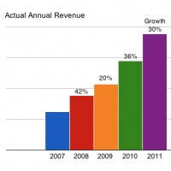

✓ Grew 120k sign-ups for end-to-end $375k dollar annual PPC spend campaign for sector leading employment industry client, including strategy and implementation.

✓ Doubled annual revenue for Software as a Service startup by, outperforming better-funded competitors by 60% using web channels with PPC and SEO.

✓ Increased click-thru-rate for corporate sales training e-commerce store by 110%, decreased cost-per-click by 12% and increased conversion rate by 250%.
Client Testimonials

“Protea Digital has been managing our PPC campaigns for several years. Protea Digital has proven to be quite adept in managing our business. Our revenue has consistently grown with Steven's guidance. Protea has generated a significant amount of incremental sales. In short we are very satisfied with Protea. Steven is professional, easy to communicate with, responsive, creative, and attentive to our needs. I recommend Protea Digital with no hesitation.”
-Tom Muscalino, CEO Thomas Lee Ltd, Former President of WestPoint Pepperell

“Protea Digital have done an excellent job. They understand the importance of measuring ROI
and have done an excellent job of demonstrating this."
-Winston Bowden, VP Marketing, Contactology

“Again, thank you for all your hard work and fast response on our requests and fixes. You are great at what you do and have accomplished for Laser Image.”
-Cynthia Luks, Laser Image Printing and Marketing

“Thanks for being so professional and easy to work with!”
- Linda, eFulfillment Services Inc

“Many thanks go to Protea Digital for the web marketing they provided.”
- Stuart, TrueBridge Capital Partners

"You are awesome, thank you."
- Julie Jones, Awesome Eyeglasses

Partial Client List
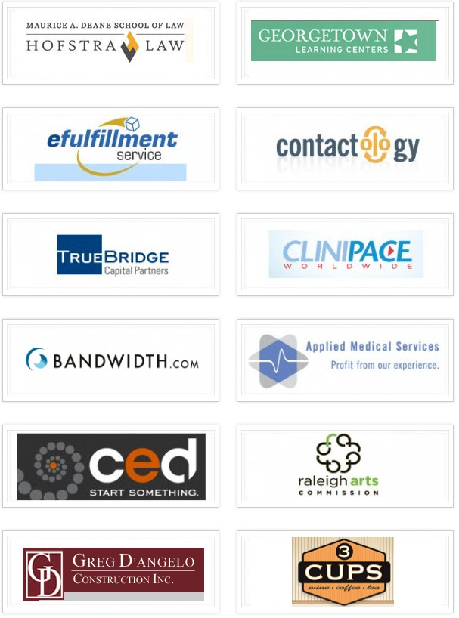

Relevant Certifications

Google Adwords Certified ID 883-883-7576





Next Steps

We strongly believe we can help the FDA Group grow through smart digital marketing. We would enjoy partnering with you as your ‘digital marketing department’. We have worked with high-growth companies before, and got great results, and we’d like to help the FDA Group do the same.

If you'd like to move forward, please email Steve at spkent@proteadigital.com

Thanks Tim.

